**FI 393**

**Chapter 3—Time Value of Money 1: Analyzing Single Cash Flows**

**Notes Outline**

1. Why learn how to value cash flows?

* In both business and personal life, **cash flows** are _**PAID**__ and __**RECIVED**_ at some point in the *__****FUTURE****__*.
  + Ex: A business may contract to build a building like the Student Commons in exchange for a $25 million payment when construction is complete in 3 years.
    - Is this the same as receiving a $25 million payment today?
    - __**NO**__! Why…?
    - Because the $25 million received today can earn **_INTEREST___** over the 3-year period between now and completion of the building.
    - So, $25 million received today will be worth **_MORE_ than $25 million** 3 years from now.
  + Ex: You are one day hoping to retire, right?
    - How much money will you need at age 65 in order to have a quality retirement? $1 million?
    - How much do you need to invest now in order to have $1 million in 40-45 years?
    - What investments offer the kind of return you need to earn over this 40+ years?

1. Because $*100 received TODAY (apple)* is _**NOT**_ the same as *$100 received 1 year in the future (orange)*, we need some method for comparing them fairly—apples-to-apples—rather than apples-to-oranges.
   * **Time Value of Money (TVM)** calculations allow us to make these apples-to-apples comparisons and allow us to _**COMBINE**__ the cash flows as we wish.
   * Which is worth more--$100 received today or $100 received 1 year from now?
     1. The $100 received _**TODAY**_ because in one year it will be worth _**TODAY**_ than $100.
     2. But how **MUCH***_* more? $108? $115? $120?
     3. The answer varies depending on current **_________ ________—**therate at which the $100 can be invested.

When we make TVM decisions, we need to consider the following factors:

* + **_______** of the cash flows
  + **_______** between the cash flows
  + **_______** of return we can earn.

1. We will use the time line to visually represent items over time. Let’s start with fruit.

If I gave you apples, one per year beginning today and ending 2 years from today, then you can easily conclude that I had given you a total of three apples.

Visually, this would look like:

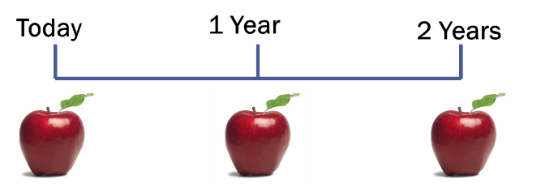

1. But money doesn’t work this way. If I gave you $100 each year, how much money would you have in total?

$300, right?

**Wrong!**

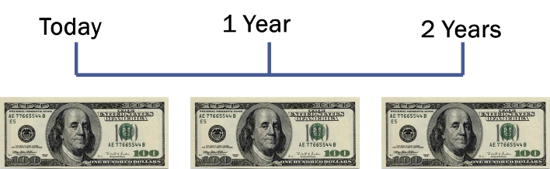

The difference between time and fruit is that **MONEY CAN WORK FOR YOU OVER TIME< EARNING YOU INTEREST**

1. Which would you rather receive: A or B?

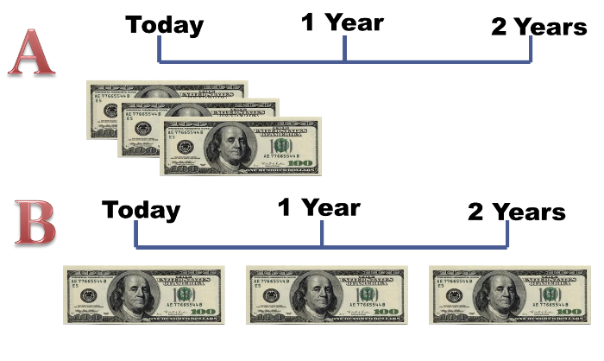__**A**__ is better because

___**BECAUSE YOU GET ALL THE MONEY TODAY INSTEAD OF WAITING**__

1. Receiving money _**ONE YEAR FROM NOW**___ or ___**TWO YEARS FROM NOW**__, is different

than getting __**THE MONEY TODAY**__.

1. Going back to the fruit analogy, receiving money over time is like receiving __**DIFFEERENT FRUITS OVERTIME**_

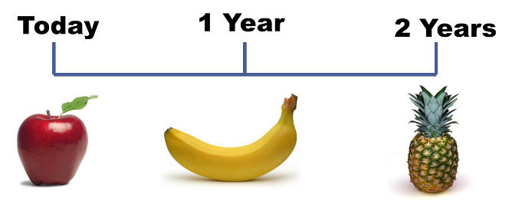

**And you can’t add up an apple, banana and pineapple and conclude that you have 3 apples!** Thus, every time you see money spread out over time, you must think of the money as different; you can’t _**JUST ADD IT UP**__!

1. The difference between fruit (and anything else) and money is that money __***CHANGES VALUE OVER TIME***___
2. Money received over time is not equal in value.

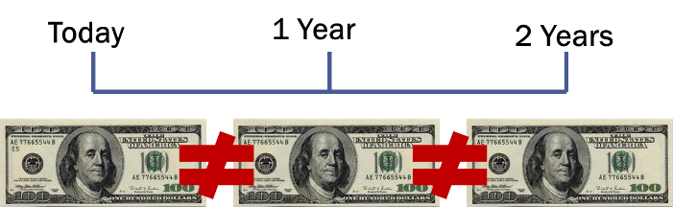

So how do we “value” future money? That’s the important question we are addressing!

1. **Basic Definitions**

Inflow: __**CASH RECEIVED (A POSITIVE #)**__

Outflow: ___***CASH OUTGOING (A NEGATIVE #)***__

Present value: Money at the beginning OR ___**THE VALUE TODAY OF A FUTURE CASH FLOW**__

Future value: Money at the end OR ___**THE VALUE OF CASH FLOW AFTER ONE OR MORE PERIODS**__

Interest rate: **__”EXCHANGE RATE” BETWEEN MONEY TODAY (PV) AND MONEY LATER (FV)** __

* The Interest rate is also called:

Discount Rate, Cost of Capital, Opportunity Cost of Capital, Required Return, or Required Rate of Return.

1. **Future Values.** Suppose that today you make a $100 deposit at your bank and your bank pays you 5% interest. How much is that $100 worth in one year?

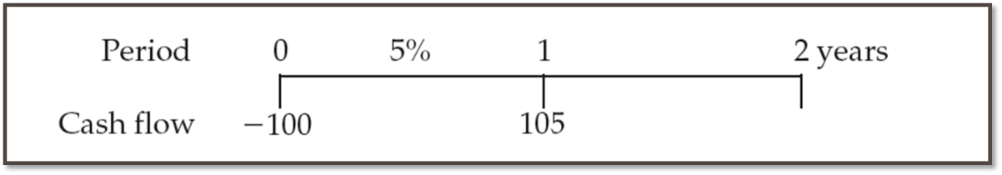

Interest = __**100 x 5%**_ = __**100 x 0.05 = $5_**

Value in 1 year = Original Deposit + Interest = _**100 + 5**__ = **_$105**_

* In this example, the ***future value*** is the **_$105**_ balance in your account at the end of year 1.
* The ***present value*** is the **_$100**_ you initially deposited.
* The ***interest rate*** is the **_5%**__ rate the bank paid to you.
* The ***time period*** was __**1 YEAR**__.
* In the example we just completed, we found the value in 1 year by adding the original deposit and the interest earned:

*Value in 1 year = ___________________________*

* Note that this is the same as:

*Value in 1 year = ____________________________*

* All that we did was factor the 100 out of the two components.
  + When you factor $100 out of the first component, you are left with a **1**.
  + When you factor the $100 out of the second component, you are left with **0.05**.
  + So, we can add the remaining **1** and **0.05** 🡪 (1+ 0.05) = 1.05
  + We need the **1** in the equation to recapture the original deposit and the **0.05** for the interest earned.
* We can generalize this equation to any amount of today’s cash flow (_**PRESENT VALUE__ aka PV) and any __INTEREST RATE**__ **(r)**.
* So, the Future Value **(FV)** in 1 year is:

*Value in 1 year = Today’s Value x (1 + Interest rate)*

*FV1 = __****PV x (1 + r)*** *__*

* So, if instead of 5%, we earn 6% interest on our $100, then:

*FV1 = __****100 x (1+ 0.06)__***

*FV1 =* ***__$106****__*

* All else unchanged, a higher interest rate 🡪 _**HIGHER_ FV**.

1. Now suppose that you leave the money in for another year:

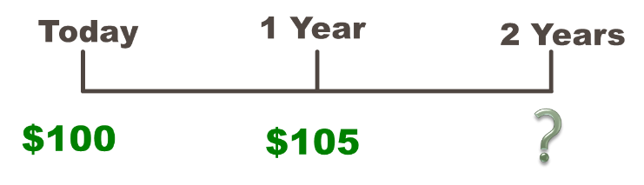

How much will you have 2 years from now?

*FV2 = ______****100_x (1 + 0.05) x (1 + 0.05) = $110.25****___*

* $_**100**__ is the original deposit, $_**5**_ is the interest from year 1 and $__**5.25**__ is interest from year 2.

1. **Compounding and Future Value.** 
   * So, year 2 interest is **$_5.25**__, but was only $__**5_**_ for year 1.
   * Where did the extra $__**0.25**___ in interest in year 2 come from?
   * **Interest on interest**

The $5 added at the end of year 1 earned $__**0.25**__ interest and the original $100 earned $__**5**__

* + **_COMPOUNDING__** is the process of earning interest on both the original deposit AND the reinvested earnings.
  + **__SIMPLE INTERET__** is the interest that is earned only on the original deposit.

1. **Simple interest vs. Compound interest**

Consider the previous example:

* + FV with simple interest = ___**100 + 5 + 5 = $110**__
  + FV with compound interest = **__$110.25**____
  + The extra $_**0.25**_ comes from the interest of _**0.05(5)**__ earned on the first interest payment or “interest on interest”

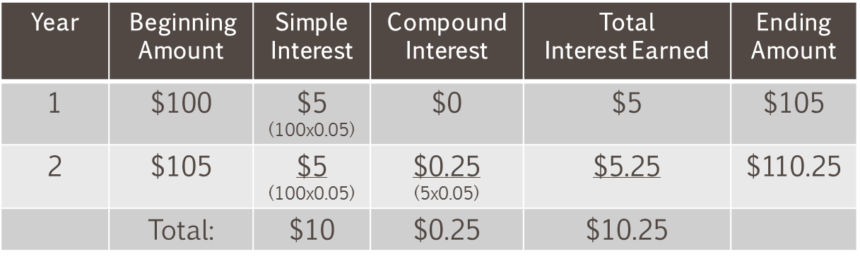

1. **Future Values: General Formula**

* If we take our previous example on out to 3 years, the equation would look like:

*FV3 = ___****100 x (1 + 0.05) x_ (1 + 0.05) x (1 + 0.05)*** *___*

* Where the last (1 + 0.05) is the interest compounded in year 3.
  + We could take this formula as far out as we want, and the result will be that we will have (1 + 0.05) for each year we extend the problem.
* So, our formula for computing FV can be generalized for any number of years (*t*):

***FVt = PV x (1 + r)t***

Where:

**FV = __FUTURE VALUE_**

**PV = _PRESENT VALUE_**

**r = __PERIOD INTERES RATE (IN DECMAL FORM) ___**

**t = __NUMBER OF PERIODS_**

1. **Using Your Financial Calculator.**

Texas Instruments BAII Plus

FV = future value

PV = present value

I/Y = periodic interest rate

* P/Y must equal 1 for I/Y to be the periodic rate
* Interest is entered as a percent, not a decimal. (5% = “5”, not “0.05”)

N = number of periods

**Remember to clear the registers (CLR TVM) after each problem!**

Set the number of decimal places to display at least 4:

* Press ***2nd*** key,
* Press ***Format*** key (above “.”),
* Enter desired decimal places (e.g., **4**).
* Press ***Enter*** to set the displayed choice.

Be sure “payment per period” or P/Y is set to “1”

* + Press ***2nd*** key,
  + Press ***P/Y*** (above ***I/Y***),
  + Enter “***1***”,
  + Press ***Enter***
  + Press *CE/C*

1. **Future Value Example—**Now assume that we leave our $100 in the account earning 5% interest for 35 years. What will the account balance be at the end of this time period?

***FV = __100 (1.05)^35 = $551.60__***

* Of the $_**_551.60_**__, how much was the original deposit, simple interest and compound interest?
  + Original Deposit = $_**100**_
  + Simple Interest = __$**5 x 35 yrs = $175**__
  + Compound interest must be the rest!
  + Compound Interest = ___**_$551.60 - $100 – 175 = $276.60**__
* The _**Higher_**_ the interest rate, the __**HIGHER_**_ the effect of compounding.

Solving this problem on the TI BA II+, the calculator inputs are:

N = __**35**___

I/Y = _**5_**_

PV = __1**00**_

CPT FV = ___**-551.60 (Positive)** _

1. **Future Values—Example.** Suppose you had a relative deposit $10 at 5.5% **200** years ago. How much will you have today?

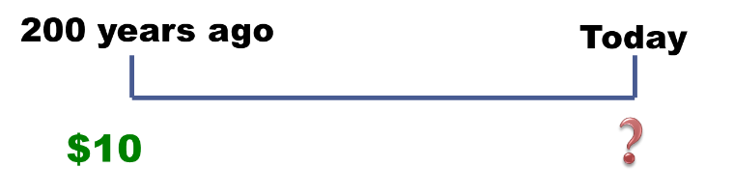N = ____________

I/Y = ___________

PV = ___________

CPT FV = ______________

OR:

FV = PV(1+r)t = 10(1.055)200 = 10(44,718.9839) = _______________

1. **Present Values.**

If we can go forward in time to the future (FV), then why can’t we go backward in time to the present (PV)?

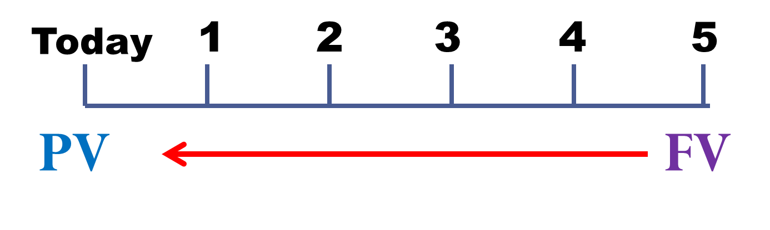We can! All we need to do is refocus our concept of moving money through time.

1. **Present Values.** IDEA: How much do I have to invest today to have some amount in the future?

We know how to find FV:

$$FV=PV{(1+r)}^{t}$$

Just rearrange to solve for PV:

$$PV=\frac{FV}{{(1+r)}^{t}}$$

1. When we talk about “________________,” we mean finding the present value of some future amount.
   * For example, if the bank is willing to give you $105 in 1 year and interest rates are 5%, how much would you be willing to deposit now to receive the payment in a year?
   * The answer is going to be something less than $____—so the value today (PV) is _______________ relative to the FV.
   * When we talk about the “________” of something, we are talking about the ___________ _____________ unless we specifically indicate that we want the future value.
2. **PV and FV.** Finance uses “_______________________” as the verb for going into the future and “_______________________” as the verb to bring funds into the present.

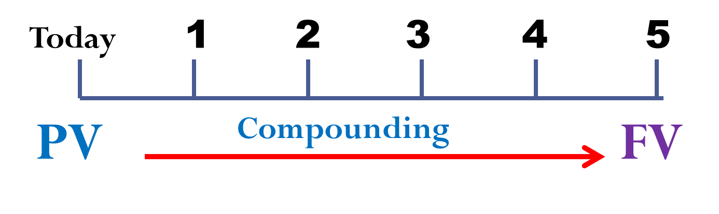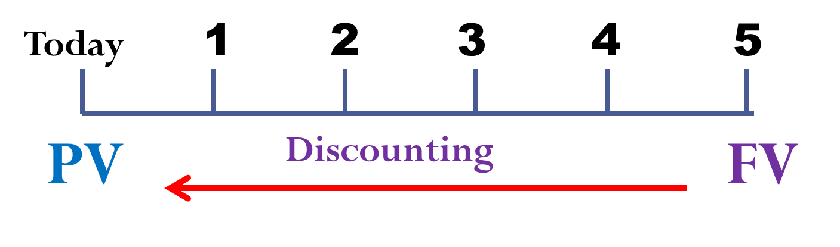

1. **Present Value: One Period Example.** Suppose the bank offers to pay you $105 in 1 year and interest rates are currently 5%. What would you be willing to deposit today in order to receive that payment?

OR in the Calculator:

N = _________

I/Y = ________

FV = __________

CPT PV =_____________

To see how this works, if you deposit ________________ today and earn 7% on the account, you should have $10,000 in a year.

PV = ________________ N = ________ I/Y = _________ CPT FV = _______________

1. 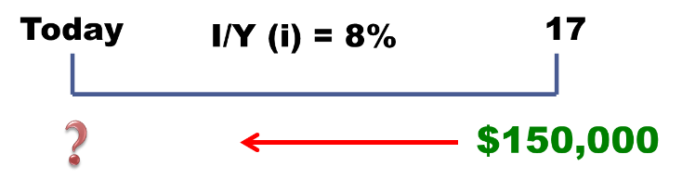**Present Values—Multiple Periods.** You want to begin saving for your daughter’s college education and you estimate that she will need $150,000 in 17 years. If you feel confident that you can earn 8% per year, how much do you need to invest today?

N = _________

I/Y = ________

FV = __________

CPT PV =_____________

**(remember the sign convention)**

1. **Present Value Important Relationship I.**

For a given ________________________, the longer the ______________________, the lower the present value.

What is the PV of $500 to be received in 5 years? 10 years? This discount rate is 10%.

5 years: N = _________ I/Y = ________ FV = ___________ CPT PV = _____________

10 years: N = _________ I/Y = ________ FV = ___________ CPT PV = ____________

1. **Present Value Important Relationship II.**

For a given __________________________, the higher the _____________________, the lower the present value.

What is the PV of $500 received in 5 years if the interest rate is 10%? 15%?

Rate = 10%: N = _______ I/Y = ________ FV = ___________, CPT PV = __________

Rate = 15%: N = _______ I/Y = ________ FV = ___________, CPT PV = __________

1. **The Basic PV Equation Review.**

$$PV= \frac{FV}{{(1+r)}^{t}}$$

There are four parts to this equation: (1) PV, (2) FV, (3) r and (4) t.

* If we know any three, we can solve for the fourth.
* If you are using a financial calculator, be sure to remember the sign convention or you will receive an error (or a nonsense answer) when solving for *r* or *t.*

***+CF = Cash INFLOW -CF = Cash OUTFLOW***

1. **Computing Interest (Discount) Rates.**

* Time value of money relationships are handy when we know two _**CASH FLOWS**_ and need to find the _**INTEREST RATE**_.
* For example, if you bought a gold coin for $350 three years ago and sell it today for $475, what rate of return have you earned?
* These types of questions are best answered using your financial calculator as the math can get a little tricky.

**PV = _-350_**

**FV = _475_**

**N = __3__**

**I/Y =? _10.72%_**

* However, you can rearrange our basic PV equation to solve for the interest rate by hand.

$$FV=PV{(1+r)}^{t}$$

$$r={\left(\frac{FV}{PV}\right)}^{\left(\frac{1}{t}\right)}-1$$

1. **Discount Rate—Example 1.** You are looking at an investment that will pay $1,200 in 5 years if you invest $1,000 today. What is the implied rate of interest?

Calculator note—the sign convention matters!

N = _**5**__

PV = -1,000 (you pay $1,000 today)

FV = 1,200 (you receive 1,200 in 5 years)

CPT I/Y = _**3.7137%**___

1. **Discount Rate—Example 2.** Suppose you are offered an investment that will allow you to double your money in 6 years. You have $10,000 to invest. What is the implied rate of interest?

N = _**6**__

PV = ___**-10,000**__

FV = __**20,000**___

CPT I/Y = ____**12.25**_

1. **Discount Rate—Example 3.** Suppose you have a 1-year old son and you want to provide $75,000 in 17 years towards his college education. You currently have $5,000 to invest. What interest rate must you earn to have the $75,000 when you need it?

N = ____**17**_______

PV = __***-75,000***__

FV = ____**5,000**___

CPT I/Y = __**17.27%**__

1. **Solving for Number of Periods.**

* At some point, you may need to determine the __**TIME PERIOD**__ (or _**Number**__ of __**PERIOD**_) needed to accumulate a specific amount of money.
* If you know the starting cash flow, the interest rate, and the future cash flow, you can solve for the number of periods needed to accumulate the FV.

Start with the basic equation and solve for *t* (remember your logs):

$$FV=PV{\left(1+r\right)}^{t}$$

$$t=\frac{\ln\left(\frac{FV}{PV}\right)}{ln⁡(1+r)}$$

You can use the financial keys on the calculator as well; just remember the sign convention.

1. **Number of Periods—Example 1.** You want to purchase a new car, and you are willing to pay $20,000. If you can invest at 10% per year and you currently have $15,000, how long will it be before you have enough money to pay cash for the car?

I/Y = _**10%**_

PV = _**-15,000**_

FV = __**20,000**__

CPT N = _**3.02 yrs**_

1. **Number of Periods—Example 2.** Suppose you want to buy a new house. You currently have $15,000, and you figure you need to have a 10% down payment plus an additional 5% of the loan amount for closing costs. Assume the type of house you want will cost about $150,000 and you can earn 7.5% per year. How long will it be before you have enough money for the down payment and closing costs?

How much do you need to have in the future?

* Down payment = __**0.10(150,000)=$15,000**_
* Closing costs = ___**(0.05)(150,000-15,000)=6750**__
* Total Needed = __**15,000+6750=21750**__

Compute the number of Periods:

I/Y = __**7.5%**__

PV = __**-15,000**__

FV = __**21,750**_

CPT N = __***5.14 yrs***__

1. **Terminology:**

Future Value Present Value

Compounding Discounting

Simple Interest Compound Interest

Discount Rate Required Rate of Return

1. **Formulas:**
$$FV=PV{\left(1+r\right)}^{t}$$

$$PV= \frac{FV}{{(1+r)}^{t}}$$

$$r={\left(\frac{FV}{PV}\right)}^{\left(\frac{1}{t}\right)}-1$$

$$t=\frac{\ln\left(\frac{FV}{PV}\right)}{ln⁡(1+r)}$$

2. What are the most important topics of this chapter?

* Time changes the value of money as money can be reinvested.
* Money received today is worth more in the future (earns interest).
* Money received in the future is worth less today.
* The interest rate (or discount rate) and time determine the change in value of an investment.
* The longer money is invested, the more compounding will increase the future value.